EXPERIMENT – 2
Encryption – Crypto 101 using TryHackMe Platform

Aim
To understand the fundamentals of cryptography by performing hands-on exercises in the Crypto 101 room on the TryHackMe platform, including basic encryption, encoding, hashing, and cryptographic concepts.

Tools / Platform Required
- Web browser (Chrome / Firefox)
- Internet connection
- TryHackMe account (free)
- Built-in TryHackMe terminal (AttackBox) or local Linux machine

Theory (Brief)
Cryptography is the practice of securing information by converting plain text into unreadable format (cipher text) using encryption techniques.
Crypto 101 introduces basic concepts such as:
- Encoding vs Encryption
- Symmetric and Asymmetric encryption
- Hashing
- Common ciphers (Caesar, Base64, etc.)

Steps to Perform the Experiment

Step 1: Log in to TryHackMe
- Open a browser and go to: https://tryhackme.com
- Log in using your registered credentials.

Step 2: Open Crypto 101 Room
- In the search bar, type Crypto 101
- Click on the room named Crypto 101
- Click Join Room

Step 3: Start the Machine (if required)
- Click Start Machine / Start AttackBox
- Wait for the virtual environment to load.

Step 4: Perform Cryptography Tasks
Complete the tasks provided in the room, such as:

4.1 Encoding & Decoding

(a) Base64 Encoding / Decoding
Purpose:
Base64 is an encoding technique used to represent binary data in a readable ASCII format.

How to Solve

To Decode Base64
- Copy the given Base64 string from the question.
- Open the TryHackMe terminal.
- Use the command:
echo "Q3J5cHRvZ3JhcGh5" | base64 -d

- The output will be the decoded plain text.
- Enter the decoded text into the answer box.

To Encode Base64
echo "cryptography" | base64

Expected Output Example: Cryptography

(b) Hexadecimal Conversion
Purpose:
Hexadecimal is a base-16 encoding system commonly used in computing.

How to Solve

Hex to Text
echo 48656c6c6f | xxd -r -p

Text to Hex
echo "Hello" | xxd -p

Expected Output: Hello

4.2 Classical Ciphers

(a) Caesar Cipher
Purpose:
Caesar cipher shifts letters by a fixed number.

How to Solve
- Identify the shift value (given or by trial).
- Use online Caesar decoder or terminal tool.

Using terminal
echo "KHOOR" | tr 'A-Z' 'X-ZA-W'

(Shift = 3)
Expected Output: HELLO

(b) Shift-Based Encryption
Purpose:
Similar to Caesar cipher but may use different shift values.

How to Solve
- Try different shift values until meaningful text appears.
- Online tools can be used if allowed.

Example:
- Shift 1 → incorrect
- Shift 3 → readable text → correct answer

4.3 Hashing

(a) Understanding Hash Algorithms

Hash Type | Length
MD5 | 32 characters
SHA-1 | 40 characters
SHA-256 | 64 characters

(b) Identifying Hashes
How to Solve
      - Count the number of characters in the given hash.
      - Match it with the table above.
Example:
5d41402abc4b2a76b9719d911017c592

→ 32 characters → MD5
Generating Hashes
echo -n "hello" | md5sum
echo -n "hello" | sha1sum
echo -n "hello" | sha256sum

4.4 Encryption Concepts
(a) Encryption vs Hashing

Encryption | Hashing
Reversible | Irreversible
Uses keys | No keys
Used for secure communication | Used for password storage

(b) Symmetric vs Asymmetric Encryption

Symmetric | Asymmetric
One key | Two keys
Fast | Slower
Example: AES | Example: RSA

Step 5: Verify Completion
- Ensure all tasks are marked Completed
- Observe the success message at the end of the room

Output


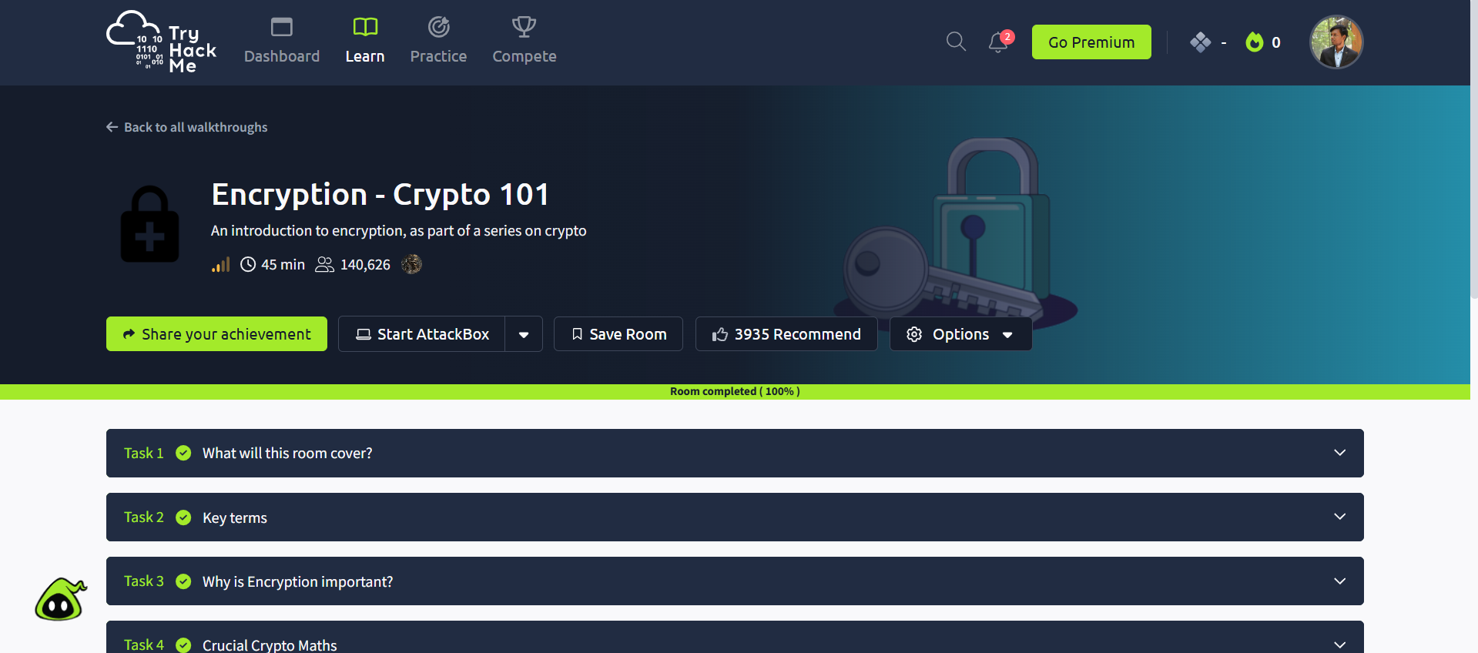

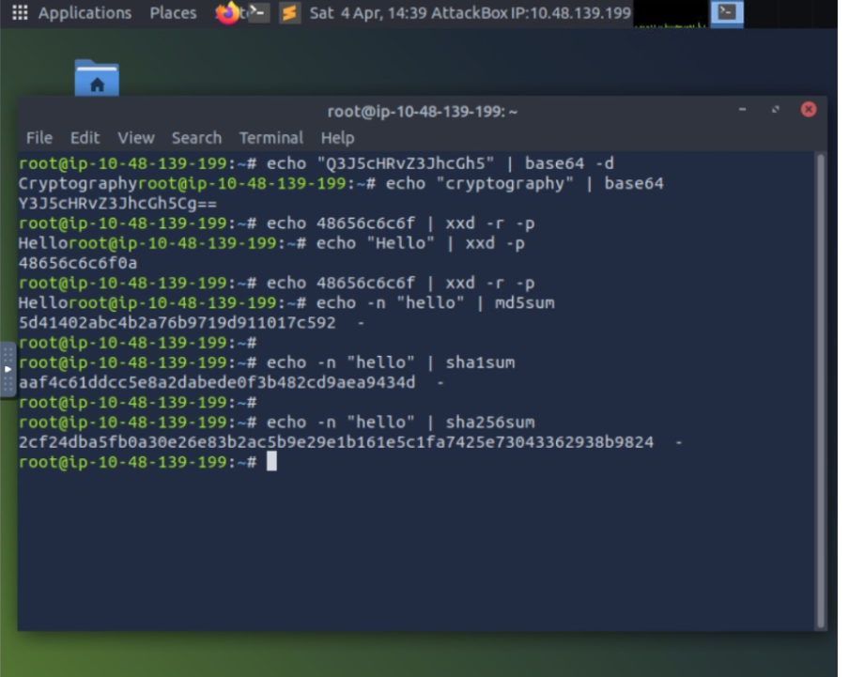

Result
Thus, the Crypto 101 experiment was completed on the TryHackMe platform.
The experiment helped in understanding basic cryptographic concepts, encryption techniques, encoding methods, and hashing algorithms through hands-on practice.

